**4.1 REQUIREMENT ANALYSIS:**

**Software Environment**

## Java Technology

* Java technology is both a programming language and a platform.

### The Java Programming Language

### The Java programming language is a high-level language that can be characterized by all of the following buzzwords:

* + - Simple
    - Architecture neutral
    - Object oriented
    - Portable
    - Distributed
    - High performance
    - Interpreted
    - Multithreaded
    - Robust
    - Dynamic
    - Secure
* With most programming languages, you either compile or interpret a program so that you can run it on your computer. The Java programming language is unusual in that a program is both compiled and interpreted. With the compiler, first you translate a program into an intermediate language called Java byte codes —the platform-independent codes interpreted by the interpreter on the Java platform. The interpreter parses and runs each Java byte code instruction on the computer. Compilation happens just once; interpretation occurs each time the program is executed. The following figure illustrates how this works.
* 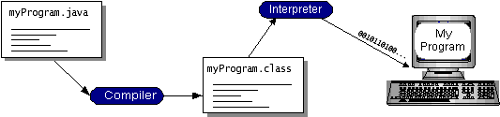

You can think of Java byte codes as the machine code instructions for the Java Virtual Machine (Java VM). Every Java interpreter, whether it’s a development tool or a Web browser that can run applets, is an implementation of the Java VM. Java byte codes help make “write once, run anywhere” possible. You can compile your program into byte codes on any platform that has a Java compiler. The byte codes can then be run on any implementation of the Java VM. That means that as long as a computer has a Java VM, the same program written in the Java programming language can run on Windows 2000, a Solaris workstation, or on an iMac.

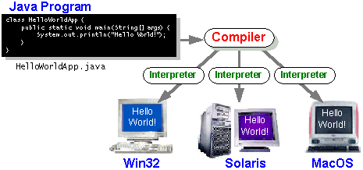

### The Java Platform

* A platform is the hardware or software environment in which program runs. We’ve already mentioned some of the most popular platforms like Windows 2000, Linux, Solaris, and MacOS. Most platforms can be described as a combination of the operating system and hardware. The Java platform differs from most other platforms in that it’s a software-only platform that runs on top of other hardware-based platforms.

The Java platform has two components:

* The Java Virtual Machine (Java VM)
* The Java Application Programming Interface (Java API)

You’ve already been introduced to the Java VM. It’s the base for the Java platform and is ported onto various hardware-based platforms.

The Java API is a large collection of ready-made software components that provide many useful capabilities, such as graphical user interface (GUI) widgets. The Java API is grouped into libraries of related classes and interfaces; these libraries are known as packages. The next section, What Can Java Technology Do? Highlights what functionality some of the packages in the Java API provide.

The following figure depicts a program that’s running on the Java platform. As the figure shows, the Java API and the virtual machine insulate the program from the hardware.

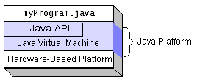

Native code is code that after you compile it, the compiled code runs on a specific hardware platform. As a platform-independent environment, the Java platform can be a bit slower than native code. However, smart compilers, well-tuned interpreters, and just-in-time byte code compilers can bring performance close to that of native code without threatening portability.

## What Can Java Technology Do?

The most common types of programs written in the Java programming language are applets and applications. If you’ve surfed the Web, you’re probably already familiar with applets. An applet is a program that adheres to certain conventions that allow it to run within a Java-enabled browser.

However, the Java programming language is not just for writing cute, entertaining applets for the Web. The general-purpose, high-level Java programming language is also a powerful software platform. Using the generous API, you can write many types of programs.

An application is a standalone program that runs directly on the Java platform. A special kind of application known as a **server** serves and supports clients on a network. Examples of servers are Web servers, proxy servers, mail servers, and print servers. Another specialized program is a **servlet**. A servlet can almost be thought of as an applet that runs on the server side. Java Servlets are a popular choice for building interactive web applications, replacing the use of CGI scripts. Servlets are similar to applets in that they are runtime extensions of applications. Instead of working in browsers, though, servlets run within Java Web servers, configuring or tailoring the server. How does the API support all these kinds of programs? It does so with packages of software components that provides a wide range of functionality. Every full implementation of the Java platform gives you the following features:

* **The essentials**: Objects, strings, threads, numbers, input and output, data structures, system properties, date and time, and so on.
* **Applets**: The set of conventions used by applets.
* **Networking**: URLs, TCP (Transmission Control Protocol), UDP (User Data gram Protocol) sockets, and IP (Internet Protocol) addresses.
* **Internationalization**: Help for writing programs that can be localized for users worldwide. Programs can automatically adapt to specific locales and be displayed in the appropriate language.
* **Security**: Both low level and high level, including electronic signatures, public and private key management, access control, and certificates.
* **Software components**: Known as JavaBeansTM, can plug into existing component architectures.
* **Object serialization**: Allows lightweight persistence and communication via Remote Method Invocation (RMI).
* **Java Database Connectivity (JDBCTM)**: Provides uniform access to a wide range of relational databases.

The Java platform also has APIs for 2D and 3D graphics, accessibility, servers, collaboration, telephony, speech, animation, and more. The following figure depicts what is included in the Java 2 SDK.

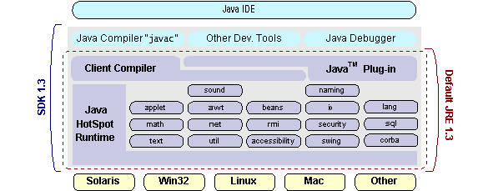

## How Will Java Technology Change My Life?

We can’t promise you fame, fortune, or even a job if you learn the Java programming language. Still, it is likely to make your programs better and requires less effort than other languages. We believe that Java technology will help you do the following:

* **Get started quickly**: Although the Java programming language is a powerful object-oriented language, it’s easy to learn, especially for programmers already familiar with C or C++.
* **Write less code**: Comparisons of program metrics (class counts, method counts, and so on) suggest that a program written in the Java programming language can be four times smaller than the same program in C++.
* **Write better code**: The Java programming language encourages good coding practices, and its garbage collection helps you avoid memory leaks. Its object orientation, its JavaBeans component architecture, and its wide-ranging, easily extendible API let you reuse other people’s tested code and introduce fewer bugs.
* **Develop programs more quickly**: Your development time may be as much as twice as fast versus writing the same program in C++. Why? You write fewer lines of code and it is a simpler programming language than C++.
* **Avoid platform dependencies with 100% Pure Java**: You can keep your program portable by avoiding the use of libraries written in other languages. The 100% Pure JavaTMProduct Certification Program has a repository of historical process manuals, white papers, brochures, and similar materials online.
* **Write once, run anywhere**: Because 100% Pure Java programs are compiled into machine-independent byte codes, they run consistently on any Java platform.
* **Distribute software more easily**: You can upgrade applets easily from a central server. Applets take advantage of the feature of allowing new classes to be loaded “on the fly,” without recompiling the entire program.

### ODBC

Microsoft Open Database Connectivity (ODBC) is a standard programming interface for application developers and database systems providers. Before ODBC became a de facto standard for Windows programs to interface with database systems, programmers had to use proprietary languages for each database they wanted to connect to. Now, ODBC has made the choice of the database system almost irrelevant from a coding perspective, which is as it should be. Application developers have much more important things to worry about than the syntax that is needed to port their program from one database to another when business needs suddenly change.

Through the ODBC Administrator in Control Panel, you can specify the particular database that is associated with a data source that an ODBC application program is written to use. Think of an ODBC data source as a door with a name on it. Each door will lead you to a particular database. For example, the data source named Sales Figures might be a SQL Server database, whereas the Accounts Payable data source could refer to an Access database. The physical database referred to by a data source can reside anywhere on the LAN.

The ODBC system files are not installed on your system by Windows 95. Rather, they are installed when you setup a separate database application, such as SQL Server Client or Visual Basic 4.0. When the ODBC icon is installed in Control Panel, it uses a file called ODBCINST.DLL. It is also possible to administer your ODBC data sources through a stand-alone program called ODBCADM.EXE. There is a 16-bit and a 32-bit version of this program and each maintains a separate list of ODBC data sources.

From a programming perspective, the beauty of ODBC is that the application can be written to use the same set of function calls to interface with any data source, regardless of the database vendor. The source code of the application doesn’t change whether it talks to Oracle or SQL Server. We only mention these two as an example. There are ODBC drivers available for several dozen popular database systems. Even

Excel spreadsheets and plain text files can be turned into data sources. The operating system uses the Registry information written by ODBC Administrator to determine which low-level ODBC drivers are needed to talk to the data source (such as the interface to Oracle or SQL Server). The loading of the ODBC drivers is transparent to the ODBC application program. In a client/server environment, the ODBC API even handles many of the network issues for the application programmer.

The advantages of this scheme are so numerous that you are probably thinking there must be some catch. The only disadvantage of ODBC is that it isn’t as efficient as talking directly to the native database interface. ODBC has had many detractors make the charge that it is too slow. Microsoft has always claimed that the critical factor in performance is the quality of the driver software that is used. In our humble opinion, this is true. The availability of good ODBC drivers has improved a great deal recently. And anyway, the criticism about performance is somewhat analogous to those who said that compilers would never match the speed of pure assembly language. Maybe not, but the compiler (or ODBC) gives you the opportunity to write cleaner programs, which means you finish sooner. Meanwhile, computers get faster every year.

**JDBC**

In an effort to set an independent database standard API for Java; Sun Microsystems developed Java Database Connectivity, or JDBC. JDBC offers a generic SQL database access mechanism that provides a consistent interface to a variety of RDBMSs. This consistent interface is achieved through the use of “plug-in” database connectivity modules, or drivers. If a database vendor wishes to have JDBC support, he or she must provide the driver for each platform that the database and Java run on.

To gain a wider acceptance of JDBC, Sun based JDBC’s framework on ODBC. As you discovered earlier in this chapter, ODBC has widespread support on a variety of platforms. Basing JDBC on ODBC will allow vendors to bring JDBC drivers to market much faster than developing a completely new connectivity solution.

JDBC was announced in March of 1996. It was released for a 90 day public review that ended June 8, 1996. Because of user input, the final JDBC v1.0 specification was released soon after.

The remainder of this section will cover enough information about JDBC for you to know what it is about and how to use it effectively. This is by no means a complete overview of JDBC. That would fill an entire book.

### JDBC Goals

Few software packages are designed without goals in mind. JDBC is one that, because of its many goals, drove the development of the API. These goals, in conjunction with early reviewer feedback, have finalized the JDBC class library into a solid framework for building database applications in Java.

The goals that were set for JDBC are important. They will give you some insight as to why certain classes and functionalities behave the way they do. The eight design goals for JDBC are as follows:

1. **SQL Level API**

The designers felt that their main goal was to define a SQL interface for Java. Although not the lowest database interface level possible, it is at a low enough level for higher-level tools and APIs to be created. Conversely, it is at a high enough level for application programmers to use it confidently. Attaining this goal allows for future tool vendors to “generate” JDBC code and to hide many of JDBC’s complexities from the end user.

1. **SQL Conformance**

SQL syntax varies as you move from database vendor to database vendor. In an effort to support a wide variety of vendors, JDBC will allow any query

statement to be passed through it to the underlying database driver. This allows the connectivity module to handle non-standard functionality in a manner that is suitable for its users.

1. **JDBC must be implemental on top of common database interfaces**  
   The JDBC SQL API must “sit” on top of other common SQL level APIs. This goal allows JDBC to use existing ODBC level drivers by the use of a software interface. This interface would translate JDBC calls to ODBC and vice versa.
2. **Provide a Java interface that is consistent with the rest of the Java system**

Because of Java’s acceptance in the user community thus far, the designers feel that they should not stray from the current design of the core Java system.

1. **Keep it simple**

This goal probably appears in all software design goal listings. JDBC is no exception. Sun felt that the design of JDBC should be very simple, allowing for only one method of completing a task per mechanism. Allowing duplicate functionality only serves to confuse the users of the API.

1. **Use strong, static typing wherever possible**

Strong typing allows for more error checking to be done at compile time; also, less error appear at runtime.

1. **Keep the common cases simple**

Because more often than not, the usual SQL calls used by the programmer are simple SELECT’s, INSERT’s, DELETE’s and UPDATE’s, these queries should be simple to perform with JDBC. However, more complex SQL statements should also be possible.

Finally, we decided to proceed the implementation using Java Networking.

And for dynamically updating the cache table we go for MS Access database.

Java ha two things: a programming language and a platform.

Java is a high-level programming language that is all of the following

Simple Architecture-neutral

Object-oriented Portable

Distributed High-performance

Interpreted multithreaded

Robust Dynamic

Secure

Java is also unusual in that each Java program is both compiled and interpreted. With a compile you translate a Java program into an intermediate language called Java byte codes the platform-independent code instruction is passed and run on the computer.

Compilation happens just once; interpretation occurs each time the program is executed. The figure illustrates how this works.

**JavaProgram**

**Compilers**

**Interpreter**

**My Program**

You can think of Java byte codes as the machine code instructions for the Java Virtual Machine (Java VM). Every Java interpreter, whether it’s a Java development tool or a Web browser that can run Java applets, is an implementation of the Java VM. The Java VM can also be implemented in hardware.

Java byte codes help make “write once, run anywhere” possible. You can compile your Java program into byte codes on my platform that has a Java compiler. The byte codes can then be run any implementation of the Java VM. For example, the same Java program can run Windows NT, Solaris, and Macintosh.

## Networking

### TCP/IP stack:

The TCP/IP stack is shorter than the OSI one.

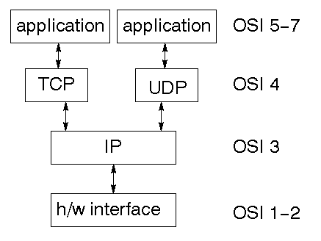

TCP is a connection-oriented protocol; UDP (User Datagram Protocol) is a connectionless protocol.

### IP datagram’s

The IP layer provides a connectionless and unreliable delivery system. It considers each datagram independently of the others. Any association between datagram must be supplied by the higher layers. The IP layer supplies a checksum that includes its own header. The header includes the source and destination addresses. The IP layer handles routing through an Internet. It is also responsible for breaking up large datagram into smaller ones for transmission and reassembling them at the other end.

### UDP

### UDP is also connectionless and unreliable. What it adds to IP is a checksum for the contents of the datagram and port numbers. These are used to give a client/server model - see later.

### TCP

### TCP supplies logic to give a reliable connection-oriented protocol above IP. It provides a virtual circuit that two processes can use to communicate.

### Internet addresses

In order to use a service, you must be able to find it. The Internet uses an address scheme for machines so that they can be located. The address is a 32 bit integer which gives the IP address. This encodes a network ID and more addressing. The network ID falls into various classes according to the size of the network address.

### Network address

Class A uses 8 bits for the network address with 24 bits left over for other addressing. Class B uses 16 bit network addressing. Class C uses 24 bit network addressing and class D uses all 32.

### Subnet address

Internally, the UNIX network is divided into sub networks. Building 11 is currently on one sub network and uses 10-bit addressing, allowing 1024 different hosts.

### Host address

8 bits are finally used for host addresses within our subnet. This places a limit of 256 machines that can be on the subnet.

### Total address

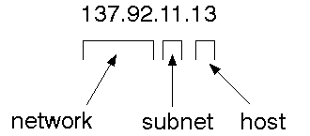

The 32 bit address is usually written as 4 integers separated by dots.

### Port addresses

A service exists on a host, and is identified by its port. This is a 16 bit number. To send a message to a server, you send it to the port for that service of the host that it is running on. This is not location transparency! Certain of these ports are "well known".

**Sockets**

A socket is a data structure maintained by the system to handle network connections. A socket is created using the call socket. It returns an integer that is like a file descriptor. In fact, under Windows, this handle can be used with Read File and Write File functions.

#include <sys/types.h>

#include <sys/socket.h>

intsocket(int family, int type, int protocol);

Here "family" will be AF_INET for IP communications, protocol will be zero, and type will depend on whether TCP or UDP is used. Two processes wishing to communicate over a network create a socket each. These are similar to two ends of a pipe - but the actual pipe does not yet exist.

**JFree Chart**

JFreeChart is a free 100% Java chart library that makes it easy for developers to display professional quality charts in their applications. JFreeChart's extensive feature set includes:

A consistent and well-documented API, supporting a wide range of chart types;

A flexible design that is easy to extend, and targets both server-side and client-side applications;

Support for many output types, including Swing components, image files (including PNG and JPEG), and vector graphics file formats (including PDF, EPS and SVG);

JFreeChart is "open source" or, more specifically, [free software](http://www.gnu.org/philosophy/free-sw.html). It is distributed under the terms of the [GNU Lesser General Public Licence](http://www.gnu.org/licenses/lgpl.html) (LGPL), which permits use in proprietary applications.

## 1. Map Visualizations

Charts showing values that relate to geographical areas. Some examples include: (a) population density in each state of the United States, (b) income per capita for each country in Europe, (c) life expectancy in each country of the world. The tasks in this project include:

Sourcing freely redistributable vector outlines for the countries of the world, states/provinces in particular countries (USA in particular, but also other areas);

Creating an appropriate dataset interface (plus default implementation), a rendered, and integrating this with the existing XYPlot class in JFreeChart;

Testing, documenting, testing some more, documenting some more.

## . Time Series Chart Interactivity

Implement a new (to JFreeChart) feature for interactive time series charts --- to display a separate control that shows a small version of ALL the time series data, with a sliding "view" rectangle that allows you to select the subset of the time series data to display in the main chart.

## 3. Dashboards

There is currently a lot of interest in dashboard displays. Create a flexible dashboard mechanism that supports a subset of JFreeChart chart types (dials, pies, thermometers, bars, and lines/time series) that can be delivered easily via both Java Web Start and an applet.

## 4. Property Editors

The property editor mechanism in JFreeChart only handles a small subset of the properties that can be set for charts. Extend (or reimplement) this mechanism to provide greater end-user control over the appearance of the charts.

**J2ME (Java 2 Micro edition):-**

Sun Microsystems defines J2ME as "a highly optimized Java run-time environment targeting a wide range of consumer products, including pagers, cellular phones, screen-phones, digital set-top boxes and car navigation systems." Announced in June 1999 at the JavaOne Developer Conference, J2ME brings the cross-platform functionality of the Java language to smaller devices, allowing mobile wireless devices to share applications. With J2ME, Sun has adapted the Java platform for consumer products that incorporate or are based on small computing devices.

**1. General J2ME architecture**



J2ME uses configurations and profiles to customize the Java Runtime Environment (JRE). As a complete JRE, J2ME is comprised of a configuration, which determines the JVM used, and a profile, which defines the application by adding domain-specific classes. The configuration defines the basic run-time environment as a set of core classes and a specific JVM that run on specific types of devices. We'll discuss configurations in detail in the Theprofile defines the application; specifically, it adds domain-specific classes to the J2ME configuration to define certain uses for devices. We'll cover profiles in depth in the The following graphic depicts the relationship between the different virtual machines, configurations, and profiles. It also draws a parallel with the J2SE API and its Java virtual machine. While the J2SE virtual machine is generally referred to as a JVM, the J2ME virtual machines, KVM and CVM, are subsets of JVM. Both KVM and CVM can be thought of as a kind of Java virtual machine -- it's just that they are shrunken versions of the J2SE JVM and are specific to J2ME.

**. Developing J2ME applications**

Introduction In this section, we will go over some considerations you need to keep in mind when developing applications for smaller devices. We'll take a look at the way the compiler is invoked when using J2SE to compile J2ME applications. Finally, we'll explore packaging and deployment and the role preverification plays in this process.

**3.Design considerations for small devices**

Developing applications for small devices requires you to keep certain strategies in mind during the design phase. It is best to strategically design an application for a small device before you begin coding. Correcting the code because you failed to consider all of the "gotchas" before developing the application can be a painful process. Here are some design strategies to consider:

* Keep it simple. Remove unnecessary features, possibly making those features a separate, secondary application.

Smaller is better. This consideration should be a "no brainer" for all developers. Smaller applications use less memory on the device and require shorter installation times. Consider packaging your Java applications as compressed Java Archive (jar) files.

* Minimize run-time memory use. To minimize the amount of memory used at run time, use scalar types in place of object types. Also, do not depend on the garbage collector. You should manage the memory efficiently yourself by setting object references to null when you are finished with them. Another way to reduce run-time memory is to use lazy instantiation, only allocating objects on an as-needed basis. Other ways of reducing overall and peak memory use on small devices are to release resources quickly, reuse objects, and avoid exceptions.

**4.Configurations overview**

The configuration defines the basic run-time environment as a set of core classes and a specific JVM that run on specific types of devices. Currently, two configurations exist for J2ME, though others may be defined in the future:

* **Connected Limited Device Configuration (CLDC)**is used specifically with the KVM for 16-bit or 32-bit devices with limited amounts of memory. This is the configuration (and the virtual machine) used for developing small J2ME applications. Its size limitations make CLDC more interesting and challenging (from a development point of view) than CDC. CLDC is also the configuration that we will use for developing our drawing tool application. An example of a small wireless device running small applications is a Palm hand-held computer.

* **Connected Device Configuration (CDC)**is used with the C virtual machine (CVM) and is used for 32-bit architectures requiring more than 2 MB of memory. An example of such a device is a Net TV box.

**5.J2ME profiles**

**What is a J2ME profile?**

As we mentioned earlier in this tutorial, a profile defines the type of device supported. The Mobile Information Device Profile (MIDP), for example, defines classes for cellular phones. It adds domain-specific classes to the J2ME configuration to define uses for similar devices. Two profiles have been defined for J2ME and are built upon CLDC: KJava and MIDP. Both KJava and MIDP are associated with CLDC and smaller devices. Profiles are built on top of configurations. Because profiles are specific to the size of the device (amount of memory) on which an application runs, certain profiles are associated with certain configurations.

A skeleton profile upon which you can create your own profile, the Foundation Profile, is available for CDC.

**Profile 1: KJava**

KJava is Sun's proprietary profile and contains the KJava API. The KJava profile is built on top of the CLDC configuration. The KJava virtual machine, KVM, accepts the same byte codes and class file format as the classic J2SE virtual machine. KJava contains a Sun-specific API that runs on the Palm OS. The KJava API has a great deal in common with the J2SE Abstract Windowing Toolkit (AWT). However,

because it is not a standard J2ME package, its main package is com.sun.kjava. We'll learn more about the KJava API later in this tutorial when we develop some sample applications.

**Profile 2: MIDP**

MIDP is geared toward mobile devices such as cellular phones and pagers. The MIDP, like KJava, is built upon CLDC and provides a standard run-time environment that allows new applications and services to be deployed dynamically on end user devices. MIDP is a common, industry-standard profile for mobile devices that is not dependent on a specific vendor. It is a complete and supported foundation for mobile application

development. MIDP contains the following packages, the first three of which are core CLDC packages, plus three MIDP-specific packages.

* java.lang

* java.io

* java.util

* javax.microedition.io

* javax.microedition.lcdui

* javax.microedition.midlet

* javax.microedition.rms

**4.1.1 INPUT DESIGN:**

The input design is the link between the information system and the user. It comprises the developing specification and procedures for data preparation and those steps are necessary to put transaction data in to a usable form for processing can be achieved by inspecting the computer to read data from a written or printed document or it can occur by having people keying the data directly into the system. The design of input focuses on controlling the amount of input required, controlling the errors, avoiding delay, avoiding extra steps and keeping the process simple. The input is designed in such a way so that it provides security and ease of use with retaining the privacy. Input Design considered the following things:

* What data should be given as input?
* How the data should be arranged or coded?
* The dialog to guide the operating personnel in providing input.
* Methods for preparing input validations and steps to follow when error occur.

**OBJECTIVES**

1.Input Design is the process of converting a user-oriented description of the input into a computer-based system. This design is important to avoid errors in the data input process and show the correct direction to the management for getting correct information from the computerized system.

2.It is achieved by creating user-friendly screens for the data entry to handle large volume of data. The goal of designing input is to make data entry easier and to be free from errors. The data entry screen is designed in such a way that all the data manipulates can be performed. It also provides record viewing facilities.

3.When the data is entered it will check for its validity. Data can be entered with the help of screens. Appropriate messages are provided as when needed so that the user will not be in maize of instant. Thus, the objective of input design is to create an input layout that is easy to follow

**4.1.2 OUTPUT DESIGN**

A quality output is one, which meets the requirements of the end user and presents the information clearly. In any system results of processing are communicated to the users and to other system through outputs. In output design it is determined how the information is to be displaced for immediate need and also the hard copy output. It is the most important and direct source information to the user. Efficient and intelligent output design improves the system’s relationship to help user decision-making.

1. Designing computer output should proceed in an organized, well thought out manner; the right output must be developed while ensuring that each output element is designed so that people will find the system can use easily and effectively. When analysis design computer output, they should Identify the specific output that is needed to meet the requirements.

2.Select methods for presenting information.

3.Create document, report, or other formats that contain information produced by the system.

The output form of an information system should accomplish one or more of the following objectives.

* Convey information about past activities, current status or projections of the
* Future.
* Signal important events, opportunities, problems, or warnings.
* Trigger an action.
* Confirm an action.

**4.2 RESOURCE REQUIREMENT**

**SYSTEM REQUIREMENTS:**

**HARDWARE REQUIREMENTS:**

* System : Dual core.
* Hard Disk : 40 GB.
* Floppy Drive : 1.44 Mb.
* Monitor : 15 VGA Colour.
* Mouse : Logitech.
* Ram : 4 GB.

**SOFTWARE REQUIREMENTS:**

* Operating system : Windows XP/7/10/11.
* Coding Language : JAVA
* Data Base : MYSQL

**4.3 DESIGN PROCESS**

**PROPOSED SYSTEM**

* To achieve the forward security for public key searchable encryption, our intuition is to bind a search token (or an encrypted data file) and its generation time together.
* when processing search, the algorithm first checks whether the encrypted data file is generated before the search token. However, as well-known, it is difficult to execute number comparison operations over encrypted data

**ADVANTAGES**

* The proposed framework can achieve keyword secrecy if the underlying ABSE scheme can achieve keyword secrecy.
* PEKS can**protect user data privacy** without affecting the usage of the data stored in the untrusted cloud server environment.

**ALGORITHMS**

**ABE**

**Attribute-based encryption**

 ABE can be used for log encryption. Instead of encrypting each part of a log with the keys of all recipients, it is possible to encrypt the log only with attributes which match recipients' attributes.

**Ciphertext:**

Ciphertext is also known as encrypted or encoded information because it contains a form of the original plaintext that is unreadable by a human or computer without the proper cipher to decrypt it. Decryption, the inverse of encryption, is the process of turning ciphertext into readable plaintext.

**4.3.1 SYSTEM ARCHITECURE**

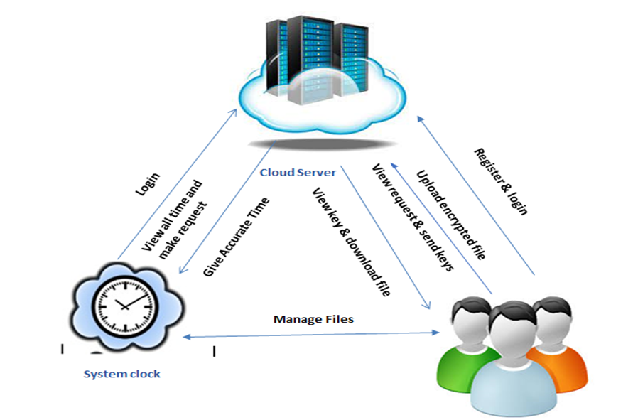

**4.3.2MODULE DESCRIPTION**

In this project has three modules:

* Data owner
* Data User
* Cloud Server

**DATA OWNER:**

* Register the account with the basic information
* After authorize by cloud owner can login the account
* Upload the file with the encrypted format
* View and manage the file
* Logout

**DATA USER:**

* Register the account with the basic information
* After authorized user can login the account
* Search the file based on the keyword, if the keyword should be matching the file means that files should be shown
* Make a request to cloud
* View key and Download the File. After the file download that should be in decrypted format.
* Logout

**CLOUD SERVER:**

* Login the account with the correct username and Password
* Authorize the owner and user
* View request for download the file and send the key
* View all files in cloud
* Graph
* Logout

**UML DIAGRAM:**

**USE CASE DIAGRAM:**

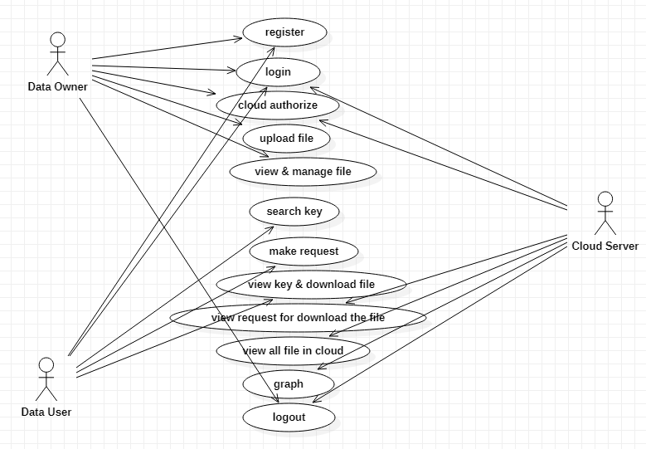

**CLASS DIAGRAM:**

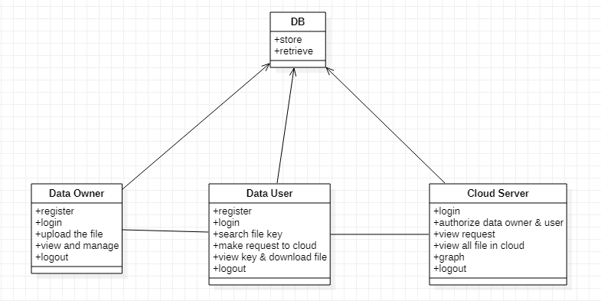

**SEQUENCE DAIGRAM:**

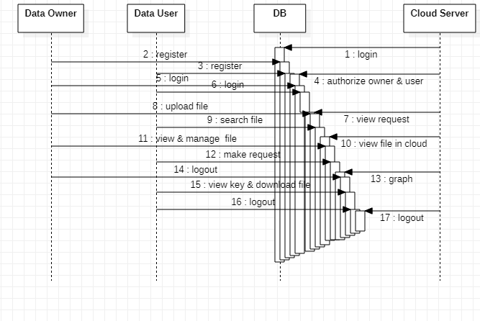

**COLABORATION DIAGRAM:**

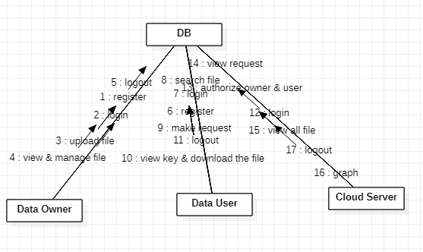

**DEPLOYMENT DAIGRAM:**

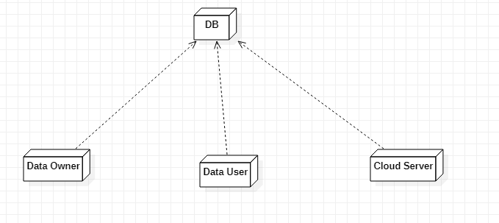

**DATAFLOW DIAGRAM:**

**LEVEL 0:**

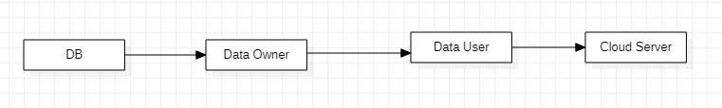

**LEVEL 1:**

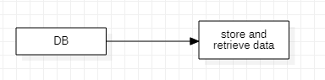

**LEVEL 2:**

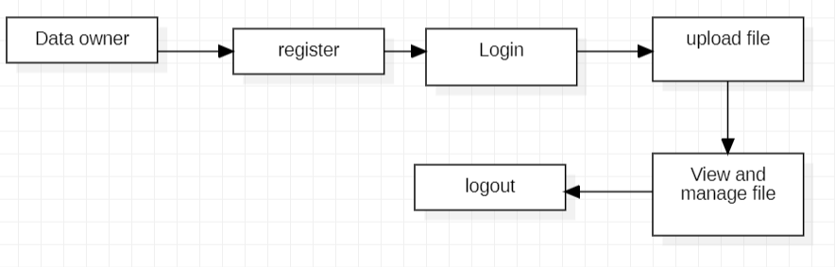

**LEVEL 3:**

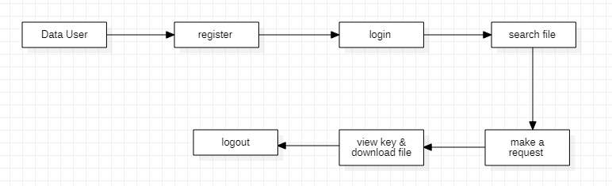

**LEVEL4:**

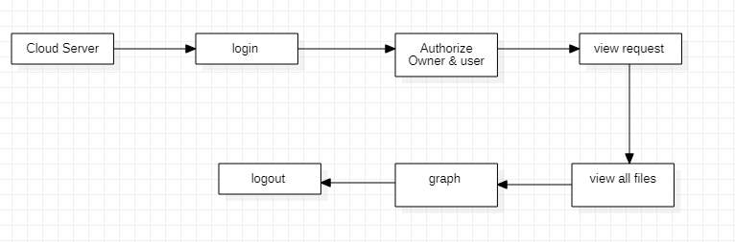

**ER DIAGRAM:**

Data User

Cloud Server

Data Owner